Appendix 2.1 Ecosystem and Socioeconomic Profile of the Pacific cod stock in the Gulf of Alaska - Report Card

S. Kalei Shotwell (Editor)

Bridget Ferriss, Peter-John F. Hulson, Ben Laurel, Beth Matta, and Lauren Rogers (Team)

November 2023

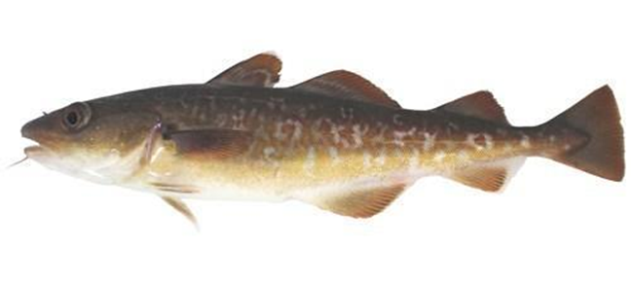

*With Contributions from:*

Anna Ableman, Grant Adams, Kerim Aydin, Steven Barbeaux, Matt Callahan, Wei Cheng, Curry Cunningham, Brian Garber-Yonts, Kirstin Holsman, Sandi Neidetcher, Krista Oke, Patrick Ressler, Heather Renner, Sean Rohan, Elizabeth Siddon, Ingrid Spies, Katie Sweeney, Muyin Wang, Stephani Zador

# Current Year Update

The ecosystem and socioeconomic profile or ESP is a standardized framework for compiling and evaluating relevant stock-specific ecosystem and socioeconomic indicators and communicating linkages and potential drivers of the stock within the stock assessment process (Shotwell et al., *Accepted*). The ESP process creates a traceable pathway from the initial development of indicators to management advice and serves as an on-ramp for developing ecosystem-linked stock assessments.

Please refer to the last full ESP document ([Shotwell et al., 2021](https://apps-afsc.fisheries.noaa.gov/refm/docs/2021/GOApcod.pdf), Appendix 2.1, pp. 161-226) which is available within the Gulf of Alaska (GOA) Pacific cod stock assessment and fishery evaluation or SAFE report for further information regarding the ecosystem and socioeconomic linkages for this stock.

## Management Considerations

The following are the summary considerations from current updates to the ecosystem and socioeconomic indicators evaluated for GOA Pacific cod:

* Heatwave events were low, summer bottom temperatures decreased to below average and habitat suitability was again slightly lower than long-term mean in 2023, unlikely limiting for survival
* Annual eddy kinetic energy remains in low energy period implying reduced larval retention and reduced cross-shelf transport to suitable nearshore nursery environments
* Spring bloom timing is very delayed which may have implications for mismatch to prey but may be tempered in cooler thermal environment, zooplankton abundances were average suggesting sufficient prey resources
* Abundance of Pacific cod larvae was again low, suggesting another poor year class, although abundances may have been higher outside the surveyed region and reproductive success of piscivorous seabirds remained above average suggesting sufficient forage fish prey resources
* Nearshore abundance of young-of-the-year (YOY) Pacific cod decreased to below average consistent with the low abundance of larval Pacific cod in the spring survey
* Juvenile Pacific cod condition remained below average while adult Pacific cod decreased slightly to average from the previous bottom trawl survey
* Center of gravity shifted slightly to the northeast concurrent with a decrease in the effective area occupied implying a slightly contracted spatial distribution
* Ex-vessel value increased but still below average, price per pound increased to above average, but revenue-per-unit-effort has increased again to highest value in the time series
* Overall, physical indicators and upper trophic indicators were average, and lower trophic indicators were above average in 2023, socioeconomic indicators were above average in 2022.

## Modeling Considerations

The following are the summary results from the intermediate and advanced stage monitoring analyses for GOA Pacific cod:

* Highest ranked predictors variables of GOA Pacific cod recruitment based on the importance methods in the intermediate stage indicator analysis were the summer bottom temperature in the GOA, and the annual eddy kinetic energy in the Kodiak area (inclusion probability > 0.5)
* Further development on ecosystem research models using indicators of temperature linked to time varying growth and a new two-year project to investigate these linkages
* Updated estimates of time-varying natural mortality and ration from the 2023 CEATTLE model run indicate that 1) age-1 natural mortality for Pacific cod has increased but remains below the long-term mean and still above the single species estimate, 2) total biomass consumed by modelled predators has decreased and below the long-term mean, and 3) ration for adult (age 4+) Pacific cod has increased but is still below the long-term mean

# 

# Assessment

## Ecosystem and Socioeconomic Processes

We summarize important processes that may be helpful for identifying productivity bottlenecks and dominant pressures on the stock in conceptual models detailing ecosystem processes by life history stage (Figure 2.1.1) and economic performance (Table 2.1.1). Please refer to the last full ESP document ([Shotwell et al., 2021](https://apps-afsc.fisheries.noaa.gov/refm/docs/2021/GOApcod.pdf)) for more details.

An analysis of commercial processing and harvesting data may be conducted to examine sustained participation for those communities substantially engaged in a commercial fishery. The Annual Community Engagement and Participation Overview (ACEPO) report evaluates engagement at the community level and focuses on providing an overview of harvesting and processing sectors of identified highly engaged communities for groundfish and crab fisheries in Alaska (Wise et al., 2022). Please refer to this report for information on community engagement in the GOA Pacific cod fishery.

## Indicator Suite

The list of ESP indicators is organized by categories, three for ecosystem indicators (physical, lower trophic, and upper trophic) and three for socioeconomic indicators (fishery performance, economic, and community). For GOA Pacific cod socioeconomic categories, only economic indicators are available at this time. A short description and contact name for the indicator contributor are provided. For ecosystem indicators, we also include the anticipated sign of the proposed relationship between the indicator and the stock population dynamics where relevant, and specify the lag applied if the indicator was tested in the intermediate stage indicator analysis. Please refer to the full ESP document for detailed information regarding the ecosystem and socioeconomic indicator descriptions and proposed mechanistic linkages for this stock ([Shotwell et al., 2021](https://apps-afsc.fisheries.noaa.gov/refm/docs/2021/GOApcod.pdf)). Time series of the ecosystem and socioeconomic indicators are provided in Figure 2.1.2a and Figure 2.1.2b, respectively.

Modifications to ecosystem indicators in 2023 include: 1) chlorophyll *a* concentration and peak timing of the spring bloom derived from MODIS satellite measurements have now been replaced with a European Space Agency (ESA) GlobColour blended satellite product because the satellites that hold the MODIS instruments will soon be retired due to changes in their orbits, 2) methods for calculating the time series for spring small copepods and summer large copepods from the EcoFOCI survey were updated to better standardize across gear types and resulted in starting the time series at 1994, 3) time-series calculations for the larval catch-per-unit-effort (CPUE) estimates on the Eco FOCI survey were updated to use a model-based approach (sdmTMB; Anderson et al. 2022) instead of the previous area-weighted mean, in part to better account for variable survey coverage in recent years due to ship-time constraints, and 4) regional quotient indicators for pollock harvesting and processing revenue in the GOA communities are no longer reported in the ESP as this community level information is provided in the ACEPO report (Wise et al., 2022). These modifications will preclude direct comparison to indicator timeseries in previous ESP documents.

### Ecosystem Indicators:

Physical Indicators (Figure 2.1.2a.a-d)

* 1. **Spawning marine heatwave** cumulative index over the central GOA (contact: S. Barbeaux). Proposed sign of relationship is negative.
  2. **Winter spring spawning habitat suitability** index from January to April in the central GOA shelf at GAK1 station (contact: L. Rogers). Proposed sign of relationship is positive and the time series is not lagged for the intermediate stage indicator analysis.
  3. **Summer bottom temperatures** where small Pacific cod (0-20 cm) have been sampled by the AFSC GOA bottom trawl survey from the CFSR model (contact: M. Wang). Proposed sign of relationship is negative and the time series is not lagged for the intermediate stage indicator analysis.
  4. **Annual eddy kinetic energy** (EKE) calculated from sea surface height in the Kodiak area (contact: W. Cheng). Proposed sign of relationship is positive and the time series is not lagged for the intermediate stage indicator analysis.

Lower Trophic Indicators (Figure 2.1.2a.e-i)

* 1. **Peak timing of the spring bloom** averaged across individual ADF&G statistical areas in the western and central GOA region calculated from ESA GlobColour blended satellite product (contact: M. Callahan). Proposed sign of relationship is positive.
  2. **Summer large copepods** for young-of-the-year (YOY) from the EcoFOCI summer survey (contact: L. Rogers). Proposed sign of relationship is positive.
  3. **Summer euphausiid abundance** for the GOA from the AFSC acoustic survey (contact: P. Ressler). Proposed sign of relationship is positive.
  4. **Spring Pacific cod larvae catch-per-unit-of-effort** (CPUE) from the EcoFOCI spring survey (contact: L. Rogers). Proposed sign of relationship is positive.
  5. **Common murre** (piscivores) **reproductive success** at Chowiet Island (contact: S. Zador). Proposed sign of relationship is positive.
  6. **Summer Pacific cod CPUE of YOY** from the AFSC Kodiak nearshore beach seine survey (contact: B. Laurel). Proposed sign of the relationship is positive.

Upper Trophic Indicators (Figure 2.1.2a.j-o)

* 1. **Summer condition for juvenile** (<420 mm) **Pacific cod** from the AFSC GOA shelf bottom trawl survey (contact: S. Rohan). Proposed sign of relationship is positive.
  2. **Summer condition for adult** (>=420 mm) **Pacific cod** from the AFSC GOA shelf bottom trawl survey (contact: S. Rohan). Proposed sign of relationship is positive.
  3. **Summer Pacific cod center of gravity northeastings** estimated by a spatio-temporal model using the package VAST on AFSC GOA bottom trawl survey data (contact: Z. Oyafuso). Proposed sign of relationship is negative.
  4. **Summer Pacific cod area occupied** estimated by a spatio-temporal model using the package VAST on AFSC GOA bottom trawl survey data (contact: Z. Oyafuso)
  5. **Arrowtooth flounder total biomass** from the most recent stock assessment model in the GOA (contact: K. Shotwell). Proposed sign of relationship is negative and the time series is lagged two years for the intermediate stage indicator analysis.
  6. **Steller sea lion non-pup estimates** for the GOA portion of the western Distinct Population Segment (contact: K. Sweeney). Proposed sign of relationship is negative and the time series is lagged two years for the intermediate stage indicator analysis.

### Socioeconomic Indicators:

Economic Indicators (Figure 2.1.2b.a-c)

* 1. Annual estimated **real ex-vessel value** of GOA Pacific cod (contact: J. Lee)
  2. Annual real **ex-vessel price per pound** of GOA Pacific cod from fish ticket information (contact: J. Lee).
  3. Annual estimated **real revenue per unit effort** measured in weeks fished of GOA Pacific cod (contact: J. Lee)

## Indicator Monitoring Analysis

There are up to three stages (beginning, intermediate, and advanced) of statistical analyses for monitoring the indicator suite listed in the previous section. The beginning stage is a relatively simple evaluation by traffic light scoring. This evaluates the current year trends relative to the mean of the whole time series, and provides a historical perspective on the utility of the whole indicator suite. The intermediate stage uses importance methods related to a stock assessment variable of interest (e.g., recruitment, growth, catchability). These regression techniques provide a simple predictive performance for the variable of interest and are run separate from the stock assessment model. They provide the direction, magnitude, uncertainty of the effect, and an estimate of inclusion probability. The advanced stage is used for testing a research ecosystem linked model and output can be compared with the current operational model to understand information on retrospective patterns, prediction performance, and comparisons of other model output.

### Beginning Stage: Traffic Light Test

We use a simple scoring calculation for this beginning stage traffic light evaluation. Indicator status is evaluated based on being greater than ("high"), less than ("low"), or within ("neutral") one standard deviation of the long-term mean. A sign based on the anticipated relationship between the indicator and the stock (generally shown in Figure 2.1.1 and specifically by indicator in the Indicator Suite, Ecosystem Indicators section) is also assigned to the indicator where possible. If a high value of an indicator generates good conditions for the stock and is also greater than one standard deviation above the mean, then that value receives a "+1" score. If a high value generates poor conditions for the stock and is greater than one standard deviation above the mean, then that value receives a "-1" score. All values less than or equal to one standard deviation from the long-term mean are average and receive a "0" score. The scores are summed by the three organizational categories within the ecosystem (physical, lower trophic, and upper trophic) or socioeconomic (fishery performance, economic, and community) indicators and divided by the total number of indicators available in that category for a given year. The scores over time allow for comparison of the indicator performance and the history of stock productivity (Figure 2.1.3). We also provide five year indicator status tables with a color (ecosystem indicators only) for the relationship with the stock (Tables 2.1.2a,b) and evaluate each year’s status in the historical indicator time series graphic (Figures 2.1.2a,b) for each ecosystem and socioeconomic indicator.

We evaluate the status and trends of the ecosystem and socioeconomic indicators to understand the pressures on the GOA Pacific cod stock regarding recruitment, stock productivity, and stock health. We start with the physical indicators and proceed through the increasing trophic levels, economic, and community indicators as listed above. Here we concentrate on updates relative to the results presented in the last ESP report card (Shotwell et al., 2022). Overall both the physical and upper trophic indicators scored average and the lower trophic indicators scored above average for 2023 (Figure 2.1.3). Compared to last year’s results, this is the same for the physical indicators a decrease for the lower and upper trophic indicators. There were no updates for the two upper trophic indicators that are usually lagged one year due to the timing of the stock assessment review and the marine mammal survey data review. We note caution when comparing scores between odd to even years as there are many lower and upper trophic indicators missing in even years due to the off-cycle year surveys in the GOA. Also, there have been other cancellations due to COVID-19 and continuing issues with staffing of NOAA white ships since 2020 that have resulted in delayed or canceled surveys, reductions in survey sampling coverage and resolution, increased uncertainty in survey results, and increased costs/reduced efficiency for surveys. This has limited production and delivery timing of several indicators. Economic indicators are all lagged by at least one year due to timing of the availability of the current year information and the production of this report. Economic indicators improved from last year and are now above average for 2022.

For physical indicators (Table 2.1.2a, Figure 2.1.2a.a-d), the presence of a series of major marine heatwaves for the past several years had increased sea surface warming and reduced Pacific cod spawning habitat suitability in the GOA ecosystem (Figure 2.1.2a.a-c). However, from 2020 through 2021 there were reduced temperatures at the bottom and reduced annual marine heatwave events from the previous warm stanza. In 2022, the summer bottom temperatures increased again to above average, but the heatwave events were low during spawning and spawning habitat suitability improved, and was higher than in any year since 2012, due to colder conditions at depth in the GOA at that time of year. In 2023, heatwave events were low, summer bottom temperatures decreased to below average and habitat suitability was again slightly lower than the long-term mean. Recent heatwave years (2015, 2016, 2019) resulted in substantial declines in spawning habitat suitability due to temperatures at depth that were warmer than optimal for hatch success of Pacific cod eggs, potentially limiting the recruitment of this stock. Since 2020, conditions have improved and spawning habitat suitability has increased. Thermal conditions in 2023 were relatively cooler and unlikely to be limiting for Pacific cod egg survival. Future warming may impact GOA Pacific cod through impacts on this thermally-sensitive early life stage. The annual eddy kinetic energy (EKE) near Kodiak remains in a low energy period similar to 2018 (Figure 2.1.2a.d) implying reduced retention in the area of young-of-the-year Pacific cod and reduced cross-shelf transport to suitable nearshore nursery environments.

For the lower trophic level indicators (Table 2.1.2a, Figure 2.1.2a.e-j), the peak timing of the spring bloom appears highly variable since the onset of the marine heatwaves in 2014 and is very delayed in 2023, similar to 2016 and 2019 (Figure 2.1.2a.e). This may have implications for mismatch between larval Pacific cod and the available plankton abundance. During warm years this may be particularly important for Pacific cod due to their increased metabolic requirements and the implications of a later bloom may be somewhat tempered in a cooler thermal environment such as in 2020, 2021, and 2023 (B. Laurel, *pers. commun*.). Late summer, large copepod abundance declined from the early 2000s until the marine heatwave of 2014-2016. In 2023, large copepod numbers were similar to recent years and slightly higher than the marine heat wave years (Figure 2.1.2a.f). Large copepod abundances are influenced by timing of the annual cohort of the dominant large species: C. marshallae, N. cristatus, and Neocalanus spp. The dominant large species in summer is C. marshallae as both other large species have likely entered diapause. Long-term variability in mesozooplankton in this region is thought to be driven by Pacific Decadal Oscillation (PDO) and El Nino-Southern Oscillation (ENSO) cycles. Zooplankton are an important prey base for larval and juvenile fishes in spring and summer. Both large copepod numbers and euphausiid abundances were average during the late summer relative to long-term trends. Both are principal diet items for juvenile fish and these numbers appear to indicate adequate forage (Figure 2.1.2a.f). There were no updates for euphausiid abundance (Figure 2.1.2a.g) due to an issue with recurring radiated noise on the survey but a data processing solution is being implemented and there may be updates in the future.

Abundance of Pacific cod larvae has been low in recent survey years (2021, 2019), similar to the low catches observed during the marine heatwave in 2015 (Figure 2.1.2a.h). In 2023, Pacific cod abundance increased from 2021 but remained low relative to the long-term mean. Catches were higher to the SW of the core sampling area. The EcoFOCI survey was truncated due to vessel staffing, resulting in only partial coverage of the core survey area. Hence, 2023 estimates have greater uncertainty (Rogers and Axler, 2023). With temperature conditions in 2023 being consistent with an “average” to "cool" climate year, we expected to observe increased abundances of Pacific cod relative to recent heatwave years. Ichthyoplankton surveys can provide early-warning indicators for ecosystem conditions and recruitment patterns in marine fishes. In both 2015 and 2019, low abundances of Pacific cod larvae was the first indication of failed year-classes for this species. In 2023, abundance of Pacific cod larvae was again low, suggesting another poor year class, although abundances may have been higher outside the surveyed region. Reproductive success of common Murre seabirds on Chowiet Is. decreased but remain above average suggesting sufficient forage fish prey resources (Figure 2.1.2a.i). Age-0 Pacific cod numbers are annually variable in the nearshore but showed steep declines during marine heatwave period (2014-16; 2019). The beach seine CPUE of YOY Pacific cod in the Kodiak summer nearshore survey decreased to below average (Figure 2.1.2a.j). Pacific cod numbers have been notably higher since 2016 in non-heatwave years, with 2022 representing a higher than average year and exceptionally high numbers caught in the Kodiak region. Factors influencing nearshore abundance of age-0 juvenile Pacific cod are part of several ongoing investigations examining spring heat stress during spawning and the early larval period (Laurel and Rogers 2020; Almeida et al. accepted). Seine CPUE estimates have been shown to be relatively good indicators of future recruitment in GOA Pacific cod (Litzow et al. 2022) but fall and 1st winter stress may reduce their predictive value with future warming (Laurel et al. 2023). The steep declines in age-0 abundance during marine heatwaves (2014-16, 2019) suggests there is poor survival of egg and larval stages in the spring. Summer nearshore habitats are highly important to age-0 Pacific cod before the they move to deeper, offshore waters at older life stages. Their availability to beach seines in the summer provide direct measures of abundance and can serve as indicators of future recruitment.

For the upper trophic indicators (Table 2.1.2a, Figure 2.1.2a.k-p), condition of juvenile Pacific cod in the GOA in 2023 was below average, similar to 2021, but within one standard deviation of the time series mean, which continues the trend of neutral morphometric condition since 2019 (Figure 2.1.2a.k). The condition of adult Pacific cod in the GOA in 2023 was average, which also continues the trend of neutral morphometric condition since 2015 (Figure 2.1.2a.l). Many factors contribute to variation in morphometric condition so it is unclear which specific factors contributed to neutral condition of juvenile and adult Pacific cod in the GOA in 2023. Factors that may contribute to variation in morphometric condition include environmental conditions that affect prey quality and temperature-dependent metabolic rates, survey timing, stomach fullness of individual fish, fish migration patterns, and the distribution of samples within survey strata (O'Leary and Rohan, 2023). In the Gulf of Alaska, elevated temperatures during the 2014–2016 marine heatwave were associated with lower growth rates of Pacific cod and lower morphometric condition in 2015 (adults and juveniles combined), likely because of a decrease in prey resources and increase in metabolic demand (Barbeaux et al., 2020). The center of gravity for GOA Pacific cod shifted slightly northeast compared to 2021 (Figure 2.1.2a.m) and the estimated effective area occupied for GOA Pacific cod moderately decreased from 2021 (Figure 2.1.2a.n). The slight northeastern shift in the center of gravity is concurrent with a decrease in the effective area occupied and a slight increase in the design-based estimate of total GOA Pacific cod biomass. The decrease in the effective area occupied in 2023 implies a slightly contracted spatial distribution covered by Pacific cod in the GOA relative to the 1990-2023 time series. Changes in the distributional characteristics of marine populations may impact the spatial distributions of fishing activities and trophic interactions (Thorson et al., 2016). The arrowtooth flounder stock assessment model was not updated in 2022 as it was an off-cycle year (Figure 2.1.2a.o). Estimates from the 2023 bottom trawl survey for arrowtooth flounder were 5% greater than in 2021 (but still below the long term mean). There were no updates for predicted counts of Steller sea lions (Figure 2.1.2a.p).

For economic indicators (Table 2.1.2b, Figure 2.1.2b.a-c), ex-vessel value in 2022 increased and is now within one standard deviation of the time series mean but remains below average and has been low since 2018 (Figure 2.1.2b.a). Price per pound increased to above average and revenue per unit effort increased to the highest value in the time series (Figure 2.1.2b.b-c). Since 2016 reductions in global supply have put upward pressure on prices resulting in significant year over year price increases in 2017 and 2018. In 2019 prices leveled off, decreasing slightly, as markets have adjusted. In 2020 COVID-19 closures resulted in increased demand for retail products and frozen products, and decreased food service and fresh products. Retail and food service are both significant components of the market for Pacific cod products. As such, the impact of COVID-19 on prices appears muted with only marginal changes in first-wholesale and export prices. Cost pressure from COVID-19 mitigation efforts likely had upstream impacts on ex-vessel prices, which decreased significantly.

### Intermediate Stage: Importance Test

Bayesian adaptive sampling (BAS) was used for the intermediate stage statistical test to quantify the association between hypothesized predictors and GOA Pacific cod recruitment and to assess the strength of support for each hypothesis. In this stage, the full set of indicators is first evaluated for normality and transformed as needed or removed. The remaining set of indicators is winnowed to the predictors that could directly relate to recruitment and highly correlated covariates (>0.6) are removed. Covariates with the strongest linked to recruitment are retained and then z-scored. We further restrict potential covariates to those that can provide the longest model run (e.g., biennial indicators would be removed) and through the most recent estimate of recruitment that is well estimated in the current operational stock assessment model. This results in a model run from 1994 through the 2019 year-class. We provide the relationship between the observed and predicted estimates (Figure 2.1.4, top panel, left side) and the fit over time (Figure 2.1.4, top panel, right side) for reference. We then provide the mean relationship between each predictor variable and log GOA Pacific cod recruitment over time (Figure 2.1.4b, left side), with error bars describing the uncertainty (95% confidence intervals) in each estimated effect and the marginal inclusion probabilities for each predictor variable (Figure 2.1.4b, right side). A higher probability indicates that the variable is a better candidate predictor of GOA Pacific cod recruitment. The highest ranked predictor variables (inclusion probability > 0.5) based on this process the summer bottom temperature from the CFSR model (inclusion probability = 0.97), and the annual eddy kinetic energy in the Kodiak area (probability = 0.53) (Figure 2.1.4).

### Advanced Stage: Research Model Test

Further development continued in 2023 on the ecosystem research models (Hulson et al. 2023) that incorporated links for catchability and growth using CFSR predicted bottom temperatures. These ecosystem linked models were presented at the September Plan Team but the growth model is not being considered for use in tactical management of the stock at this time. A new two-year project has just begun that will be investigating environmental linkages to growth for GOA Pacific cod and results from this project will be used as guidance for alternatives in future stock assessment model evaluations.

In the future, mortality switches could be evaluated in the advanced stage statistical test, which is a modeling application that analyzes predictor performance and estimates risk probabilities within the operational stock assessment model. Output of two new model developments could be used to generate or enhance an ecosystem-linked model for GOA Pacific cod. First, a new multi-species statistical catch-at-age assessment model (known as CEATTLE; Climate- Enhanced, Age-based model with Temperature-specific Trophic Linkages and Energetics; Holsman et al., 2016) has recently been developed for understanding trends in total mortality for Pacific cod, walleye pollock, and arrowtooth flounder from the GOA (Adams et al., 2022; Adams et al., 2023). Total mortality rates are based on estimates of residual mortality estimates (M1), time- and age-varying predation mortality (M2), and time- and age-varying fishing mortality (F). CEATTLE has been modified for the GOA and implemented in Template Model Builder (Kristensen et al., 2015) to allow for the fitting of multiple sources of data, time-varying selectivity, time-varying catchability, and random effects. The model is based, in part, on the parameterization and data used for the most recent stock assessment model of each species (Barbeaux et al., 2023, Monnahan et al., 2023, and Shotwell et al., 2021b). The model is fit to data from five fisheries and seven surveys, including both age and length composition assumed to come from a multinomial distribution. Model estimates of M2 are empirically driven by bioenergetics-based consumption information and diet data from the GOA to inform predator-prey suitability. The model was fit to data from 1977 to present (Figure 2.1.5, reproduced from Adams et al., 2023). Age-1 natural mortality for Pacific cod has increased in recent years, but remains below the long-term mean and above the value used for the single species assessment (Figure 2.1.5, top panel). Predation mortality for this model is primarily driven by arrowtooth flounder and total biomass of arrowtooth has declined in recent years (Shotwell et al., 2021b). Estimates of total biomass consumed of Pacific cod as prey across all ages decreased in recent years and is currently below the long term mean (Figure 2.1.5, middle panel). Annual predation demand (ration) has been steadily decreasing for Pacific cod since the mid-1990s, but has increased slightly since 2020 and remains below average in 2023 (Figure 2.1.5, bottom panel).

A spatially-explicit individual-based model (IBM) for the early life stages of Pacific cod was developed as part of the GOA Integrated Ecosystem Research Program (GOAIERP) (Hinckley et al., 2019) using the DisMELS (Dispersal Model for Early Life Stages) IBM framework. It has since been updated to include temperature-dependent egg development and a better characterization of juvenile nursery habitat based on a Habitat Suitability Model. The IBM tracks the 3-dimensional location, growth, and other characteristics of simulated individuals from the egg stage to the benthic juvenile stage using stored 4-dimensional (3-d space and time) ROMS model output to provide the spatiotemporally-varying environment (e.g., 3-dimensional temperature, NPZ, and current fields) in which the individuals "exist". Egg development and larval/juvenile growth rates depend on *in situ* temperature. Vertical movement in the water column is also stage-specific, but horizontal dispersion is currently assumed to be passive. Individual location and other characteristics are updated using Lagrangian particle tracking with a 20-minute integration time step. It would be possible to derive several types of indices using the IBM and ROMS model output for the current year, including: 1) changes in connectivity between presumed spawning and juvenile nursery habitats; 2) spatiotemporally-averaged, temperature-dependent egg development success; and 3) life stage-specific, spatiotemporally-averaged, temperature-dependent growth rates. Once the ROMS model output is available, it takes several hours on a laptop to run the IBM for a year simulating ~100,000 individuals. Additional time would be required to calculate the desired indices, but turn-around could be reasonably quick.

The age-1 mortality index could provide a gap free estimate of predation mortality. Indeed, the age-specific mortality estimates from the GOA CEATTLE model are being tested as priors for age-specific mortality within the age-structured model, however fitting age-specific annually varying mortality within the model has proven to be challenging given the lack of data on younger fish (age 0-3) and will require further development. Potentially in the future, other high importance indicators from the Intermediate Stage analysis could also be used directly to help explain the variability in recruitment deviations and predict pending recruitment events for GOA Pacific cod. The ecosystem indicators could also be used to explore linkages to time-varying growth patterns for GOA Pacific cod.

# Data Gaps and Future Research Priorities

While the metric and indicator assessments provide a relevant set of proxy indicators for evaluation at this time, there are certainly areas for improvement. The majority of indicators collected for GOA Pacific cod have a fair number of gaps due to the biennial nature of survey sampling in the GOA. This causes issues with updating the ESP and the ecosystem considerations during off-cycle years and can lead to difficulty in identifying impending shifts in the ecosystem that may impact the GOA Pacific cod population. Development of high-resolution remote sensing (e.g., regional surface temperature, transport estimates, primary production estimates) or climate model indicators (e.g., bottom temperature, nutrient-phytoplankton-zooplankton variables) would assist with the current multi-year data gap for several indicators if they sufficiently capture the main trends of the survey data and are consistently and reliably available for use.

Refinements or updates to current indicators may also be helpful. More specific phytoplankton indicators tuned to the spatial and temporal distribution of GOA Pacific cod larvae as well as phytoplankton community structure information (e.g., hyperspectral information for size fractionation) could be more useful for understanding Pacific cod larval fluctuations. Current estimates of zooplankton biomass are only available at smaller spatial scales and regional to gulf-wide estimates of zooplankton biomass as well as offshore to nearshore monitoring of Pacific cod larvae and zooplankton are needed to elucidate prey trends at the spatial scales relevant to fisheries management. Emerging evidence for GOA Pacific cod also states that energy and trophic strategies are very different between Pacific cod and pollock after settlement; therefore, it will be important to align the spatial and temporal extent of available zooplankton or other productivity indicators to the specific needs of the GOA Pacific cod stock in the future (B. Laurel, *pers. commun*.). Demographic differences in the YOY population need to be evaluated within and among larval and juvenile surveys conducted in the Central and Western GOA (currently sampling ~1000km of coastline). Size shifts in the YOY population have already been observed in marine heatwave years, but it is unclear if one or more of the following processes are involved: 1) spawning (earlier); 2) larval/juvenile growth (higher); and/or 3) larval/juvenile mortality (higher/size-selective). Ongoing research seeks to understand how climate-driven changes in size and age may also impact survival trajectories of YOY cohorts and their potential to recruit to the fishery, which will guide further indicator development.

We currently lack an indicator of predation on YOY Pacific cod during their first autumn and winter, during a period when predation mortality is thought to be significant. Sampling of predator diets in fall and winter would help to fill this gap. An index of age-1 Pacific cod from the Kodiak beach seine survey is also available and could be useful for understanding overwinter survival in reference to the age-0 index (Laurel et al., 2023). The GOA CEATTLE model is now published and has potential to provide a gap-free index of predation mortality for age-1 GOA Pacific cod (Adams et al., 2022). The Pacific cod individual based model (IBM) is also currently being updated (Shotwell et al., *In prep.*) as part of the Essential Fish Habitat (EFH) update. Information on connectivity from spawning to nursery areas and dynamic spatial distribution of egg and larval EFH could be used to create indicators for understanding early life history dynamics. Additionally, evaluating condition and energy density of juvenile and adult Pacific cod samples at the outer edge of the population may be useful for understanding the impacts of shifting spatial statistics such as center of gravity and area occupied. Information is available from the GulfWatch Alaska program that could be helpful for evaluating the eastern edge of the GOA Pacific cod population. Also, a new project has recently been funded involving a multi-model approach including the development of the GOA Ecopath models and an Atlantis ecosystem model. This project is part of the GOA Regional Action Plan and will start in 2021 with the goal of evaluating the biological reference points used for status determination of individual stocks (e.g., Pacific cod) under projected climate scenarios (M. Dorn, *pers., commun*.). The project has a three-year timeline and we hope to incorporate the results of this effort as they become available.

We plan to evaluate additional sources of socioeconomic information to determine what indicators could be provided in the ESP that are not redundant with indicators already provided in the Economic SAFE and the ACEPO report. This may result in a transition of indicators currently reported in this ESP to a different series of socioeconomic indicators in future ESPs and may include a shift in focus. Additional considerations should be given regarding the timing of the economic and community information that are delayed by 1 to several years depending on the data source from the annual stock assessment cycle. The Scientific and Statistical Committee (SSC) recently recommended that local knowledge, traditional knowledge, and subsistence information may be helpful for understanding recent fluctuations in stock health, shifts in stock distributions, or changes in size or condition of species in the fishery. We could include this information as supportive evidence and perspective on many indicators monitored within the ESP in the future.

As indicators are improved or updated, they may replace those in the current set of indicators to allow for refinement of the BAS model and potential evaluation of performance and risk within the operational stock assessment model. Incorporating additional importance methods in the intermediate stage indicator analysis may also be useful for evaluating the full suite of indicators and may allow for identifying robust indicators for potential use in the operational stock assessment model. The annual request for information (RFI) for the GOA Pacific cod ESP will include these data gaps and research priorities along with a list of potential new indicators that could be developed for the next full ESP assessment.

# Literature Cited

Abookire, A. A., J. T. Duffy-Anderson, and C. M. Jump. 2007. Habitat associations and diet of young-of-the-year Pacific cod (*Gadus macrocephalus*) near Kodiak, Alaska. Marine Biology 150:713-726.

Adams, G.D., K.K. Holsman, S.J. Barbeaux, M.W. Dorn, J.N. Ianelli, I. Spies, I.J. Stewart, and A.E. Punt. 2022. An ensemble approach to understand predation mortality for groundfish in the Gulf of Alaska. Fish. Res. 251, 106303. <https://doi.org/10.1016/j.fishres.2022.106303>.

Adams, G., K.K. Holsman, P. Hulson, C. Monnahan, K. Shotwell, I. Stewart, and A. Punt. 2023. Multispecies model estimates of time-varying natural mortality in the GOA. *In* Ferriss, B., 2023. Ecosystem Status Report 2023: Gulf of Alaska, Stock Assessment and Fishery Evaluation Report, North Pacific Fishery Management Council, 1007 West Third, Suite 400, Anchorage, Alaska 99501.

Alderdice, D. F., and C. R. Forrester. 1971. Effects of salinity, temperature, and dissolved oxygen on early development of Pacific cod (*Gadus macrocephalus*). Journal of the Fisheries Research Board of Canada 28:883-891.

Almeida LZ, Laurel BJ, Thalmann H, Miller J. *Accepted*. Warmer, earlier, faster: Cumulative effects of Gulf of Alaska heatwaves on the early life history of Pacific Cod. Elementa: Science of the Anthropocene.

Anderson, S.C., Ward, E.J., English, P.A., and Barnett, L.A.K. 2022. sdmTMB: an R package for fast, flexible, and user-friendly generalized linear mixed effects models with spatial and spatiotemporal random fields. bioRxiv. <https://doi.org/10.1101/2022.03.24.485545>.

Aydin, K., S. Gaichas, I. Ortiz, D. Kinzey, and N. Friday. 2007. A comparison of the Bering Sea, Gulf of Alaska, and Aleutian Islands large marine ecosystems through food web modeling. U.S. Dep. Commer., NOAA Tech. Memo. NMFS-AFSC-178, 298 p.

Barbeaux S. J, K. Holsman, and S. Zador. 2020. Marine heatwave stress test of ecosystem-based fisheries management in the Gulf of Alaska Pacific cod fishery. Front. Mar. Sci. 7:703. doi: 10.3389/fmars.2020.00703

Bian, X. D., X. M. Zhang, Y. Sakurai, X. S. Jin, R. J. Wan, T. X. Gao, and J. Yamamoto. 2016. Interactive effects of incubation temperature and salinity on the early life stages of Pacific cod *Gadus macrocephalus*. Deep-Sea Research Part II-Topical Studies in Oceanography 124:117-128.

Cheng, W. 2021. Eddies in the Gulf of Alaska. *In* Ferriss, B., and Zador, S., 2021. Ecosystem Status Report 2021: Gulf of Alaska, Stock Assessment and Fishery Evaluation Report, North Pacific Fishery Management Council, 1007 West Third, Suite 400, Anchorage, Alaska 99501.

Copeman, L. A., and B. J. Laurel. 2010. Experimental evidence of fatty acid limited growth and survival in Pacific cod larvae. Marine Ecology Progress Series 412:259-272.

Deary, A., L. Rogers, and K. Axler. 2021. Larval fish abundance in the Gulf of Alaska 1981-2021. *In* Ferriss, B., and Zador, S., 2021. Ecosystem Status Report 2021: Gulf of Alaska, Stock Assessment and Fishery Evaluation Report, North Pacific Fishery Management Council, 1007 West Third, Suite 400, Anchorage, Alaska 99501.

Doyle, M. J., and K. L. Mier. 2016. Early life history pelagic exposure profiles of selected commercially important fish species in the Gulf of Alaska. Deep-Sea Research Part II-Topical Studies in Oceanography 132:162-193.

Doyle, M. J., S. J. Picquelle, K. L. Mier, M. C. Spillane, and N. A. Bond. 2009. Larval fish abundance and physical forcing in the Gulf of Alaska, 1981-2003. Progress in Oceanography 80:163-187.

Fissel, B., M. Dalton, B. Garber-Yonts, A. Haynie, S. Kasperski, J. Lee, D. Lew, C. Seung, K. Sparks, M. Szymkowiak, and S. Wise. 2021. Economic status of the groundfish fisheries off Alaska, 2019. *In* Stock assessment and fishery evaluation report for the groundfish resources of the GOA and BS/AI. North Pacific Fishery Management Council, 605 W 4th Ave, Suite 306 Anchorage, AK 99501.

Hinckley S., W. Stockhausen, K.O. Coyle, B.J. Laurel, G.A. Gibson, C. Parada, A.J. Herman, M.J. Doyle, T.P. Hurst, A.E. Punt, and C. Ladd. 2019. Connectivity between spawning and nursery areas for Pacific cod (*Gadus macrocephalus*) in the Gulf of Alaska. Deep Sea Res. Part II. Topical Studies in Oceanography 165:113-126.

Hulson, P., S. Barbeaux, and I. Spies. 2023. Summary of the 2023 Recommended Model Alternatives for Gulf of Alaska Pacific cod. Report presented at the September Gulf of Alaska Groundfish Plan Team. <https://meetings.npfmc.org/Meeting/Details/3006>

Hurst, T. P., D.W. Cooper, J. S. Scheingross, E. M. Seale, B. J. Laurel, and M. L. Spencer. 2009. Effects of ontogeny, temperature, and light on vertical movements of larval Pacific cod (*Gadus macrocephalus*). Fisheries Oceanography 18:301-311.

Hurst, T. P., B. J. Laurel, and L. Ciannelli. 2010. Ontogenetic patterns and temperature-dependent growth rates in early life stages of Pacific cod (*Gadus macrocephalus*). Fishery Bulletin 108:382-392.

Laurel, J., A. W. Stoner, C. H. Ryer, T. P. Hurst, and A. A. Abookire. 2007. Comparative habitat associations in juvenile Pacific cod and other gadids using seines, baited cameras and laboratory techniques. Journal of Experimental Marine Biology and Ecology 351:42-55.

Laurel, B. J., T. P. Hurst, L. A. Copeman, and M. W. Davis. 2008. The role of temperature on the growth and survival of early and late hatching Pacific cod larvae (Gadus macrocephalus). Journal of Plankton Research 30:1051-1060.

Laurel, B. J., C. H. Ryer, B. Knoth, and A. W. Stoner. 2009. Temporal and ontogenetic shifts in habitat use of juvenile Pacific cod (*Gadus macrocephalus*). Journal of Experimental Marine Biology and Ecology 377:28-35.

Laurel, B. J., T. P. Hurst, and L. Ciannelli. 2011. An experimental examination of temperature interactions in the match-mismatch hypothesis for Pacific cod larvae. Canadian Journal of Fisheries and Aquatic Sciences 68:51-61.

Laurel, B., M. Spencer, P. Iseri, and L. Copeman. 2016. Temperature-dependent growth and behavior of juvenile Arctic cod (*Boreogadus saida*) and co-occurring North Pacific gadids. Polar Biology 39:1127-1135.

Laurel, B. J., D. Cote, R. S. Gregory, L. Rogers, H. Knutsen, and E. M. Olsen. 2017. Recruitment signals in juvenile cod surveys depend on thermal growth conditions. Canadian Journal of Fisheries and Aquatic Sciences 74:511-523.

Laurel, B.J., and L.A. Rogers. 2020. Loss of spawning habitat and pre-recruits of Pacific cod following a Gulf of Alaska Heatwave. Canadian Journal of Fisheries and Aquatic Sciences 77(4):644-650.

Laurel, B. J., Abookire, A., Barbeaux, S. J., Almeida, L. Z., Copeman, L. A., Duffy-Anderson, J., Hurst, T. P., Litzow, M. A., Kristiansen, T., Miller, J. A., Palsson, W., Rooney, S., Thalmann, H. L., & Rogers, L. A. 2023. Pacific cod in the Anthropocene: An early life history perspective under changing thermal habitats. Fish and Fisheries, 00, 1–20. <https://doi.org/10.1111/faf.12779>.

Laurel, B.J., J. Miller, H. Thalmann, Z. Almeida, and L. Rogers. 2023. Noteworthy: Gulf of Alaska Pacific cod (2017-2023). *In* Ferriss, B., 2023. Ecosystem Status Report 2023: Gulf of Alaska, Stock Assessment and Fishery Evaluation Report, North Pacific Fishery Management Council, 1007 West Third, Suite 400, Anchorage, Alaska 99501.

Litzow MA, Abookire A, Duffy-Anderson J, Laurel BJ, Malick MJ, Rogers L. 2022. Predicting year class strength for climate-stressed gadid stocks in the Gulf of Alaska, Fisheries Research. Volume 249: 106250. ISSN 0165-7836, https://doi.org/10.1016/j.fishres.2022.106250.

O'Leary, C., Laman, N., Rohan, S. 2021. Gulf of Alaska groundfish condition. *In* Ferriss, B., and Zador, S., 2021. Ecosystem Status Report 2021: Gulf of Alaska, Stock Assessment and Fishery Evaluation Report, North Pacific Fishery Management Council, 605 W 4th Ave, Suite 306, Anchorage, AK 99501.

O'Leary, C. & Rohan, S. 2023. Gulf of Alaska Groundfish Condition. *In* Ferriss, B., and Zador, S., 2023. Ecosystem Status Report 2023: Gulf of Alaska, Stock Assessment and Fishery Evaluation Report, North Pacific Fishery Management Council, 605 W 4th Ave, Suite 306, Anchorage, AK 99501.

Ormseth, O.A. and B.L. Norcross. 2009. Causes and consequences of life-history variation in North American stocks of Pacific cod. ICES Journal of Marine Science 66(2):349-357.

Piatt, J. F. 2002. Preliminary synthesis: can seabirds recover from effects of the Exxon Valdez oil spill? In Piatt, J.F. (*ed.*), Response of Seabirds to Fluctuations in Forage Fish Density. Final report to Exxon Valdez Oil Spill Trustee Council (pp 132–171; restoration project 00163M) and Minerals Management Service (Alaska OCS Region), Alaska Science Center, United States Geological Survey, Anchorage, Alaska.

Rogers, L.A., and Axler, K. 2023. Larval Fish Abundance in the Gulf of Alaska 1981-2023. In Ferriss, B., and Zador, S., 2023. Ecosystem Status Report 2021: Gulf of Alaska, Stock Assessment and Fishery Evaluation Report, North Pacific Fishery Management Council, 1007 West Third, Suite 400, Anchorage, Alaska 99501.

Shotwell, S.K., K., Blackhart, C. Cunningham, E. Fedewa, D., Hanselman, K., Aydin, M., Doyle, B., Fissel, P., Lynch, O. Ormseth, P., Spencer, S., Zador. *In Review*. Introducing the Ecosystem and Socioeconomic Profile, a proving ground for next generation stock assessments.

Shotwell, S.K., P. Hulson, B. Ferriss, B. Laurel, and L. Rogers. 2022. Ecosystem and socioeconomic profile of the Pacific cod stock in the Gulf of Alaska. Appendix 2.1 *In* Hulson, P.J.F., S.J. Barbeaux, B. Ferriss, S. McDermott, and I. Spies. 2022. Assessment of the Pacific cod stock in the Gulf of Alaska. Stock assessment and fishery evaluation report for the groundfish resources of the Gulf of Alaska. North Pacific Fishery Management Council, Anchorage, AK 99501. Pp. 112-138.

Shotwell, S.K., S. Barbeaux, B. Ferriss, B. Fissel, B. Laurel, B. Matta, L. Rogers, E. Siddon and A. Tyrell. 2021a. Ecosystem and socioeconomic profile of the Pacific cod stock in the Gulf of Alaska. Appendix 2.1 In Barbeaux, S., B. Ferriss, B. Laurel, M. Litzow, S. McDermott, J. Nielsen, W. Palsson, K. Shotwell, I. Spies, and M. Wang. 2021. Assessment of the Pacific cod stock in the Gulf of Alaska. Stock assessment and fishery evaluation report for the groundfish resources of the Gulf of Alaska. North Pacific Fishery Management Council, 1007 W 3rd Ave, Suite 400 Anchorage, AK 99501. Pp. 161-226.

Shotwell, K., I. Spies, J.N. Ianelli, K. Aydin, D.H Hanselman, W. Palsson, K. Siwicke, and E. Yasumiishi. 2021b. Assessment of the arrowtooth flounder stock in the Gulf of Alaska. *In* Stock assessment and fishery evaluation report for the groundfish resources of the Gulf of Alaska. North Pacific Fishery Mngt. Council, 605 W 4th Ave, Suite 306 Anchorage, AK 99501.

Shotwell, S.K., W. Stockhausen, G.A. Gibson, J. Pirtle, A. Deary, and C. Rooper. *In Prep*. Developing a novel approach to estimate habitat-related survival rates for early life history stages using individual-based models.

Sinclair, A.F., and Crawford, W.R. 2005. Incorporating an environmental stock-recruitment relationship in the assessment of Pacific cod (*Gadus macrocephalus*). Fisheries Oceanography, 14, 138–150.

Stark, J. W. 2007. Geographic and seasonal variations in maturation and growth of female Pacific cod (*Gadus macrocephalus*) in the Gulf of Alaska and Bering Sea. Fishery Bulletin 105:396-407.

Strasburger, W. W., N. Hillgruber, A. I. Pinchuk, and F. J. Mueter. 2014. Feeding ecology of age-0 walleye pollock (*Gadus chalcogrammus*) and Pacific cod (*Gadus macrocephalus*) in the southeastern Bering Sea. Deep-Sea Research Part II-Topical Studies in Oceanography 109:172-180.

Thorson, J.T., Pinsky, M.L., Ward, E.J., 2016. Model-based inference for estimating shifts in species distribution, area occupied, and center of gravity. Methods Ecol. Evol. 7(8), 990-1008. doi:10.1111/2041-210X.12567. URL: <http://onlinelibrary.wiley.com/doi/10.1111/2041-210X.12567/full>

Voesenek, C. J., F. T. Muijres, and J. L. van Leeuwen. 2018. Biomechanics of swimming in developing larval fish. Journal of Experimental Biology 221.

Whitehouse, A. and K. Aydin. 2021. Foraging guild biomass-Gulf of Alaska. *In* Ferriss, B. and Zador, S., 2021. Ecosystem Status Report 2021: Gulf of Alaska, Stock Assessment and Fishery Evaluation Report, North Pacific Fishery Management Council, 1007 West Third, Suite 400, Anchorage, Alaska 99501.

Wise, S., S. Kasperski, A. Abelman, J. Lee, M. Parks, and J. Reynolds. 2022. Annual Community Engagement and Participation Overview. Report from the Economic and Social Sciences Program of the Alaska Fisheries Science Center. 98 pp.

# 

# Tables

#### Table 2.1.1a. Gulf of Alaska Pacific cod catch and ex-vessel data. Total and retained catch (thousand metric tons), ex-vessel value (million US$) and price (US$ per pound), hook and line and pot gear share of catch, inshore sector share of catch, number of vessels; average and most recent five years.

|  | **2013-2017 Average** | **2018** | **2019** | **2020** | **2021** | **2022** |
| --- | --- | --- | --- | --- | --- | --- |
| Total catch K mt | 69.16 | 15.2 | 15.7 | 6.8 | 19.2 | 25.8 |
| Retained catch K mt | 66.36 | 14.4 | 14.45 | 4.84 | 16.14 | 24.18 |
| Ex-vessel value M $ | $44.41 | $14.29 | $15.74 | $4.42 | $15.35 | $26.19 |
| Ex-vessel price lb $ | $0.3 | $0.45 | $0.49 | $0.39 | $0.39 | $0.49 |
| Hook & line share of catch | 20.17% | 22.93% | 22.64% | 19.21% | 28.8% | 25.56% |
| Pot gear share of catch | 52.17% | 53.05% | 52.04% | 34.57% | 43.28% | 43.57% |
| Central Gulf share of catch | 55.58% | 46.57% | 47.23% | 71.73% | 62.55% | 66.41% |
| Shoreside share of catch | 91.1% | 87.92% | 89.27% | 98.55% | 98.95% | 88.92% |
| Vessels # | 338.4 | 152 | 176 | 100 | 186 | 206 |
| Source: NMFS Alaska Region Blend and Catch-accounting System estimates; NMFS Alaska Region At-sea Production Reports; and ADF&G Commercial Operators Annual Reports (COAR). Data compiled and provided by the Alaska Fisheries Information Network (AKFIN). | | | | | | |

#### Table 2.1.1b. Gulf of Alaska Pacific cod first-wholesale market data. First-wholesale production (thousand metric tons), value (million US$), price (US$ per pound), fillet and head and gut volume (thousand metric tons), value share, and price (US$ per pound), inshore share of value; average and most recent five years.

|  | **2013-2017 Average** | **2018** | **2019** | **2020** | **2021** | **2022** |
| --- | --- | --- | --- | --- | --- | --- |
| All Products volume K mt | 25.18 | 5.58 | 7.47 | 2.97 | 6.54 | 9.66 |
| All Products value M $ | $96.33 | $31.91 | $35.17 | $15.03 | $35.75 | $65.71 |
| All Products price lb $ | $1.74 | $2.59 | $2.14 | $2.3 | $2.48 | $3.09 |
| Fillets volume K mt | 8.07 | 2 | 2.37 | 1.12 | 2.7 | 3.8 |
| Fillets value share | 56.99% | 60.07% | 61.1% | 67.41% | 71.38% | 70.09% |
| Fillets price lb $ | $3.09 | $4.35 | $4.12 | $4.09 | $4.28 | $5.5 |
| Head & Gut volume K mt | 10.83 | 1.92 | 3.02 | 1.15 | 1.69 | 2.92 |
| Head & Gut value share | 30.73% | 27.06% | 24.22% | 23.42% | 16.16% | 17.22% |
| Head & Gut price lb $ | $1.24 | $2.04 | $1.28 | $1.39 | $1.55 | $1.76 |
| Source: NMFS Alaska Region Blend and Catch-accounting System estimates; NMFS Alaska Region At-sea Production Reports; and ADF&G Commercial Operators Annual Reports (COAR). Data compiled and provided by the Alaska Fisheries Information Network (AKFIN). | | | | | | |

#### Table 2.1.1c. Cod U.S. trade and global market data. Global production (thousand metric tons), U.S. share of global production, and Europe’s share of global production; U.S. export volume (thousand metric tons), value (million US$), and price (US$ per pound); U.S. cod consumption (estimated), and share of domestic production remaining in the U.S. (estimated); and the share of U.S. export volume and value for head and gut (H&G), fillets, China, Japan, and Germany and Netherlands; average & most recent 5 years.

|  | **2013-2017 Average** | **2018** | **2019** | **2020** | **2021** | **2022** |
| --- | --- | --- | --- | --- | --- | --- |
| Global cod catch K mt | 1797.73 | 1635.95 | 1564 | 1489.05 | 1527.47 | - |
| U.S. P. cod share of global catch | 17.5% | 14.2% | 13.5% | 11.6% | 9.8% | - |
| Europe Share of global catch* | 75.7% | 78.3% | 78.5% | 80.4% | 82.3% | - |
| Pacific cod share of U.S. catch | 99.7% | 99.9% | 99.8% | 99.7% | 99.5% | - |
| U.S. cod consumption K mt (est.) | 111.971 | 113.622 | 106.275 | 103.362 | 107.355 | 134.198 |
| Share of U.S. cod not exported | 29.9% | 35.5% | 36.8% | 45% | 53.3% | 61.3% |
| Export volume K mt | 104.09 | 73.14 | 65.1 | 44.48 | 32.52 | 33.25 |
| Export value M US$ | $312.94 | $253.37 | $217.88 | $139.4 | $101.68 | $104.91 |
| Export price lb US$ | $1.36 | $1.57 | $1.52 | $1.42 | $1.42 | $1.43 |
| Frozen (H&G) volume share | 92.18% | 90.95% | 92.31% | 92.32% | 89.44% | 87.78% |
| Frozen (H&G) value share | 90.84% | 90.42% | 90.71% | 89.83% | 84.21% | 85.86% |
| Fillets volume share | 3.25% | 4.97% | 4.68% | 5.86% | 8.73% | 10.88% |
| Fillets value share | 4.57% | 5.69% | 5.84% | 7.38% | 12.93% | 12.11% |
| China volume share | 52.93% | 47.55% | 41.52% | 39.52% | 31.36% | 47.7% |
| China value share | 50.44% | 46.46% | 40.21% | 37.35% | 28.38% | 48.04% |
| Japan volume share | 14.55% | 15.06% | 11.86% | 13.04% | 10.99% | 4.64% |
| Japan value share | 15.4% | 16.67% | 12.97% | 13.89% | 11.78% | 4.29% |
| Europe volume share* | 19.06% | 15.95% | 21.6% | 20.13% | 11.53% | 17.16% |
| Europe value share* | 20.19% | 17.67% | 23.12% | 20.69% | 10.95% | 17.39% |
| *Europe refers to: Austria, Belgium, Denmark, France, Germany, Greece, Ireland, Italy, Netherlands, Norway, Portugal, Spain, Sweden, Switzerland, and United Kingdom | | | | | | |
| Notes: Pacific cod in this table is for all U.S. Unless noted, `cod’ in this table refers to Atlantic and Pacific cod. Russia, Norway, and Iceland account for the majority of Europe’s cod catch which is largely focused in the Barents sea. Source: FAO Fisheries & Aquaculture Dept. Statistics http://www.fao.org/fishery/statistics/en. NOAA Fisheries, Fisheries Statistics Division, Foreign Trade Division of the U.S. Census Bureau, http://www.st.nmfs.noaa.gov/commercial-fisheries/foreign-trade/index. U.S. Department of Agriculture http://www.ers.usda.gov/data-products/agricultural-exchange-rate-data-set.aspx | | | | | | |

#### Table 2.1.2a. First stage ecosystem indicator analysis for GOA Pacific cod, including indicator title and the indicator status of the last five years. The indicator status is designated with text, (greater than = “high”, less than = “low”, or within 1 standard deviation = “neutral” of long-term mean). Fill color of the cell is based on the sign of the anticipated relationship between the indicator and the stock (blue or italicized text = good conditions for the stock, red or bold text = poor conditions, white = average conditions). A gray fill and text = “NA” will appear if there were no data for that year.

| **Indicator category** | **Indicator** | **2019 Status** | **2020 Status** | **2021 Status** | **2022 Status** | **2023 Status** |
| --- | --- | --- | --- | --- | --- | --- |
| Physical | Spawning Heatwave GOA Model | **high** | neutral | neutral | neutral | neutral |
| Winter Spring Pacific Cod Spawning Habitat Suitability GAK1 Model | **low** | neutral | neutral | neutral | neutral |
| Summer Temperature Bottom GOA Model | **high** | neutral | neutral | neutral | neutral |
| Annual Eddy Kinetic Energy Kodiak Satellite | neutral | *high* | neutral | neutral | neutral |
| Lower Trophic | Spring Chlorophyll a Peak WCGOA Satellite | *high* | neutral | neutral | neutral | *high* |
| Summer Large Copepod Abundance Shelikof Survey | neutral | NA | NA | NA | neutral |
| Summer Euphausiid Abundance Kodiak Survey | neutral | NA | NA | NA | NA |
| Spring Pacific Cod CPUE Larvae Shelikof Survey | neutral | NA | neutral | NA | neutral |
| Annual Common Murre Reproductive Success Chowiet Survey | *high* | NA | neutral | *high* | neutral |
| Summer Pacific Cod CPUE YOY Nearshore Kodiak Survey | neutral | *high* | neutral | neutral | neutral |
| Upper Trophic | Summer Pacific Cod Condition Juvenile GOA Survey | neutral | NA | neutral | NA | neutral |
| Summer Pacific Cod Condition Adult GOA Survey | neutral | NA | neutral | NA | neutral |
| Summer Pacific Cod Center Gravity Northeast WCGOA Model | **high** | NA | neutral | NA | neutral |
| Summer Pacific Cod Area Occupied WCGOA Model | neutral | NA | neutral | NA | neutral |
| Annual Arrowtooth Biomass GOA Model | neutral | *low* | *low* | NA | NA |
| Annual Steller Sea Lion Adult GOA Survey | neutral | neutral | neutral | NA | NA |

#### Table 2.1.2b. First stage socioeconomic indicator analysis for GOA Pacific cod, including indicator title and the indicator status of the last five years. The indicator status is designated with text, (greater than = “high”, less than = “low”, or within 1 standard deviation = “neutral” of long-term mean). A gray fill and text = “NA” will appear if there were no data for that year.

|  |  |  |  |  |  |  |
| --- | --- | --- | --- | --- | --- | --- |
| **Indicator category** | **Indicator** | **2019 Status** | **2020 Status** | **2021 Status** | **2022 Status** | **2023 Status** |
| Economic | Annual Pacific Cod Real Exvessel Value GOA Fishery | low | low | low | neutral | NA |
| Annual Pacific Cod Real Exvessel Price GOA Fishery | high | neutral | neutral | neutral | NA |
| Annual Pacific Cod Real Revenue Per Unit Effort GOA Fishery | high | low | neutral | high | NA |

# 

# Figures

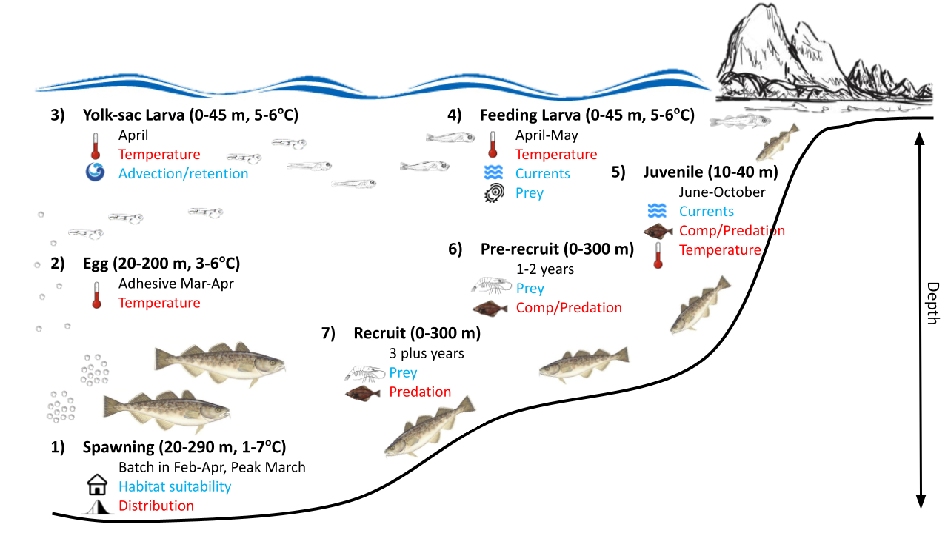

#### Figure 2.1.1: Life history conceptual model for GOA Pacific cod summarizing ecological information and key ecosystem processes affecting survival by life history stage. Red text means increases in the process negatively affect survival, while blue text means increases in the process positively affect survival.

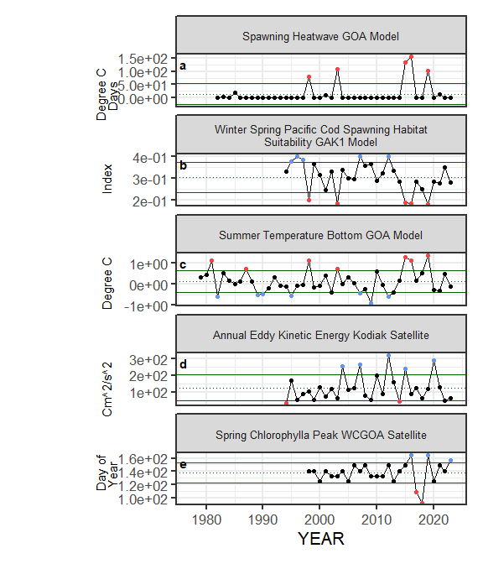

#### Figure 2.1.2a. Selected ecosystem indicators for GOA Pacific cod with time series ranging from 1977 – present. Upper and lower solid green horizontal lines represent 1 standard deviation of the time series mean. Dotted green horizontal line is the mean of the time series. Dots in the time series are colored if above or below 1 standard deviation of the time series mean and the color represents the proposed relationship for stock (blue for good conditions, red for poor conditions), black circle for neutral.

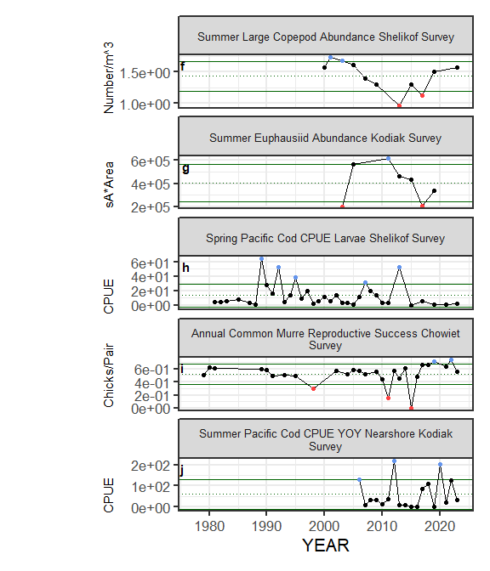

Figure 2.1.2a (cont.). Selected ecosystem indicators for GOA Pacific cod with time series ranging from 1977 – present. Upper and lower solid green horizontal lines represent 1 standard deviation of the time series mean. Dotted green horizontal line is the mean of the time series. Dots in the time series are colored if above or below 1 standard deviation of the time series mean and the color represents the proposed relationship for stock (blue for good conditions, red for poor conditions), black circle for neutral.

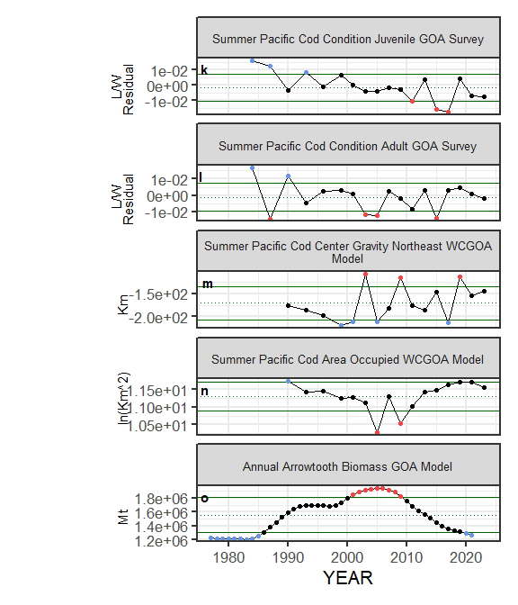

Figure 2.1.2a (cont.). Selected ecosystem indicators for GOA Pacific cod with time series ranging from 1977 – present. Upper and lower solid green horizontal lines represent 1 standard deviation of the time series mean. Dotted green horizontal line is the mean of the time series. Dots in the time series are colored if above or below 1 standard deviation of the time series mean and the color represents the proposed relationship for stock (blue for good conditions, red for poor conditions), black circle for neutral.

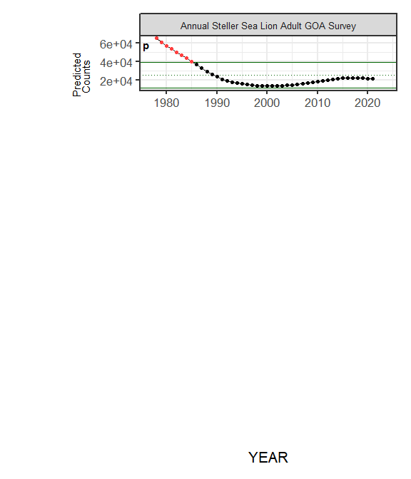

Figure 2.1.2a (cont.). Selected ecosystem indicators for GOA Pacific cod with time series ranging from 1977 – present. Upper and lower solid green horizontal lines represent 1 standard deviation of the time series mean. Dotted green horizontal line is the mean of the time series. Dots in the time series are colored if above or below 1 standard deviation of the time series mean and the color represents the proposed relationship for stock (blue for good conditions, red for poor conditions), black circle for neutral.

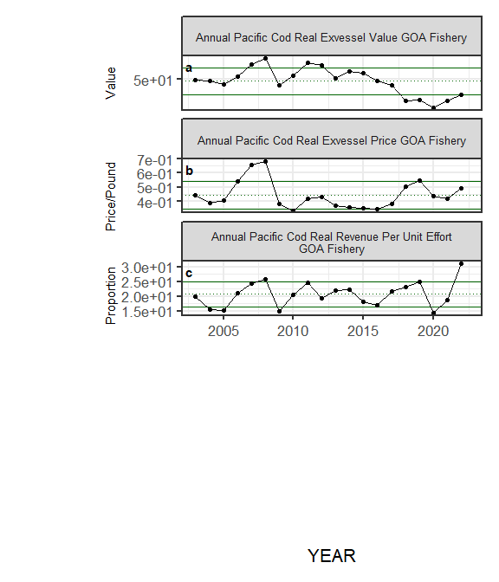

#### Figure 2.1.2b. Selected socioeconomic indicators for GOA Pacific cod with time series ranging from 1977 – present. Upper and lower solid green horizontal lines represent 1 standard deviation of the time series mean. Dotted green horizontal line is the mean of the time series.

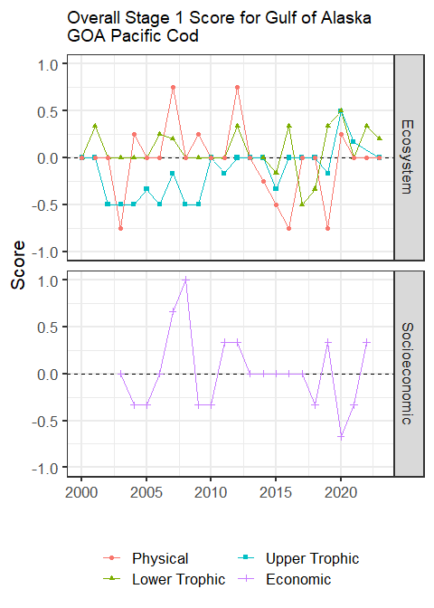

#### Figure 2.1.3: Simple summary traffic light score by category for ecosystem and socioeconomic indicators from 2000 to present.

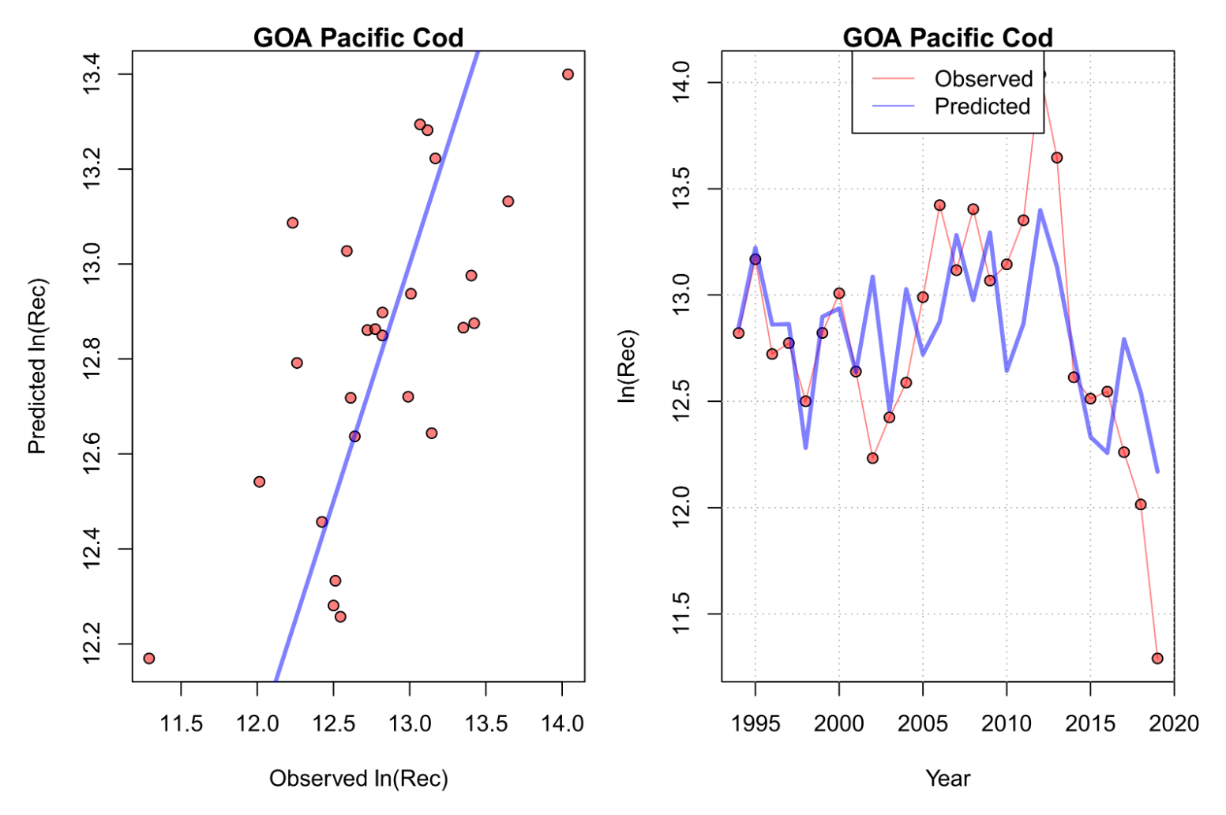

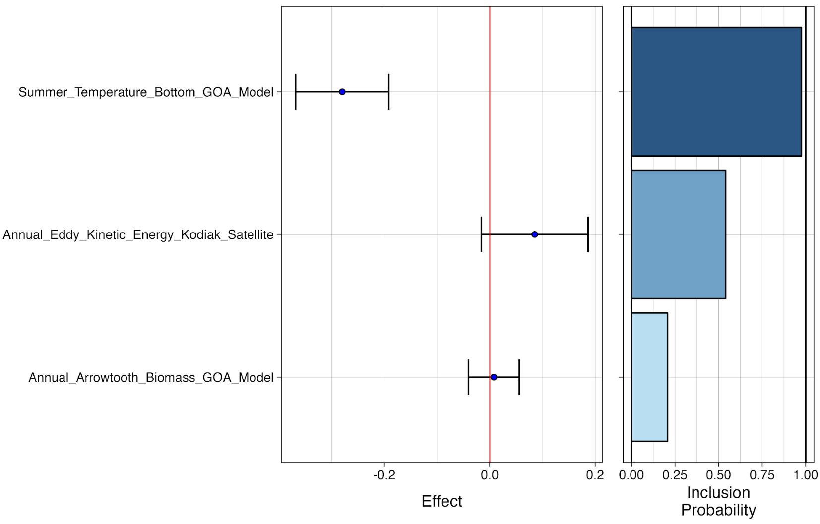

#### Figure 2.1.4: Bayesian adaptive sampling output showing (top graph) observed and predicted model fit and (bottom graph) the mean relationship and uncertainty (95% confidence intervals) with log GOA Pacific cod recruitment, in each estimated effect (left bottom graph), and marginal inclusion probabilities (right bottom graph) for each predictor variable of the subsetted covariate set.

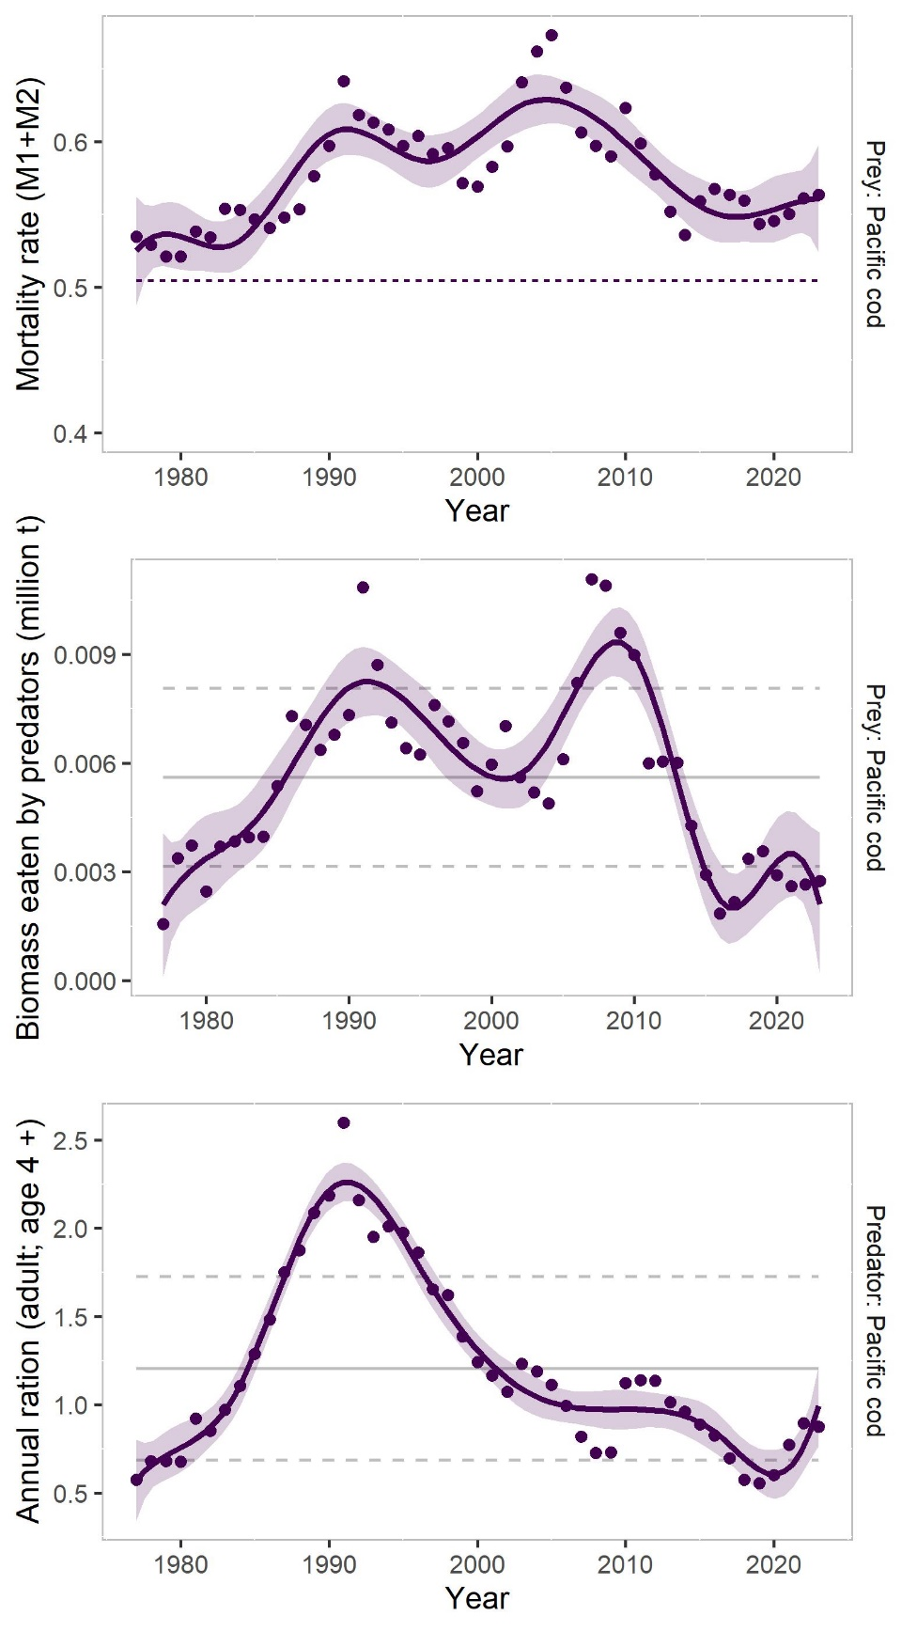

#### Figure 2.1.5: Results from the most recent CEATTLE model run (points) for Gulf of Alaska Pacific cod with loess polynomial smoother (solid line), top panel is annual variation in age-1 natural mortality (M1 + M2) and dashed line is the estimate from the single species model, middle panel is biomass (million mt) of Pacific cod consumed as prey across all ages by all predators annually in the model, and bottom panel is annual ration (100,000 tons consumed per year) for age 4 plus Pacific cod. Gray lines for middle and bottom panel are the time series mean (solid) and 1 standard deviation from the mean (dashed).